AROUND THE WORLD MEDLEY 背景スライド切り替えタイミング


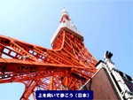
表紙

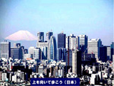
イントロが始まったら ●
上を向いて歩こう
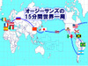
上を向いて歩こう 涙がこぼれないように●
Woo ･･･ woo ･･･ （MC） ●
AROUND THE WORLD
（演奏とMC）
・・・オージーサンズの歌の世界一周をお楽しみください ●
ON A SLOW BOAT TO CHINA
I love to get you on a slow boat to China
All to myself alone, ● get you and keep you
In my loves ever more, leave all your lovers
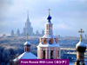
Weepin’ on a far away shore ●
FROM RUSSIA WITH LOVE
From Russia with love I fly to you
Much wiser since my good-bye to you
I raveled the world to learn I must
Return from Russia with love ●
I’ve seen places faces and smiled for a moment
But oh, you haunted me so ●
Still my tongue tied young pride
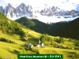
Would not let my love for you show (bon bon bon bon)
In case you’d say no ●
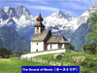
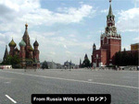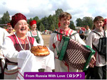
CLIMB EVERY MOUNTAIN （ｐiano）
Sound of Musicへのイントロ ●
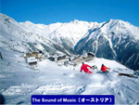
SOUND OF MUSIC
I go to the hills when my heart is lonely
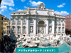
I know I will hear what I’ve heard before ●
My heart will be blessed with the sound of music
And I’ll sing once more ●
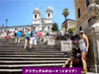
ARRVEDERCI ROMA
Arrivederci Roma goodbye good bye to Rome ●
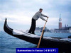
City of a/million moolit places, city of a million warm embraces
Where I found the one of all the faces far from home. ●

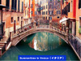
SUMMERTIME IN VENICE
I dream of the summer time of Venice and the summe r time
I see the cafe the sunlit day with you my love ●
And though I know we have to be an ocean apart
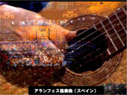
There’s Venice and you and summer-time deep in my heart ●
アランフェス協奏曲
（Gt演奏） ・・・ ● ・・・ ●
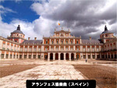
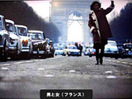

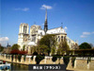
MAN AND WOMAN
Comme nos vaix ba da ba da da ba da ba da
chantent tout bas ba da ba da da ba da ba da
Nos coeursy vaient ba da ba da da ba da ba da
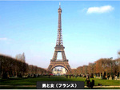
Comme une chance Comme un espoir ●
Commebien de joies Bien des drames
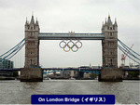
Et voila! C’est une longue historire ●
Un home Une femme ont forge la trame du hasard ●
ON LONDON BRIDGE /
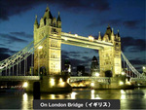
I walked on London Bridge last night
I saw you by the lamp post light ●
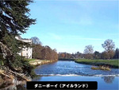
Then bells rang out in sleepy London town
And London Bridge came tumbling down ●

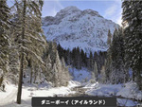
DANNY BOY
But come ye back when summer’s in the meadows
Or when the valley’s hashed and ●
While with snow
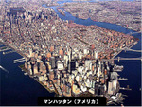
It’s I’ll be here in sunshine or in shadow /
Oh, Danny boy, oh, Danny boy, I love you so. ●
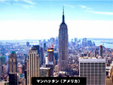
MANHATTAN
We’ll have Manhattan the Bronx and Staten Island too ●
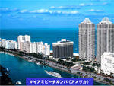
It’s lovely going through the zoo ●

マイアミビーチルンバ
（イントロのみ）●

FAIRWELL JAMAICA
Down the way where the nights are gay
And the sun shines daily on the mountain top

I took a trip on a sailing ship
And when I reached Jamaica I made a stop ●
But I'm sad to say, I'm on my way
Won't be back for many a day
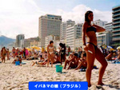
My heart is down, my head is turning around
I had to leave a little girl in Kingston town ●
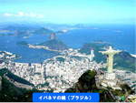
GIRL FROM IPANEMA
Tall and tan and young and lovely
The girl from Ipanema goes walking
And when she passes, each one she passes gees "Ah" ●
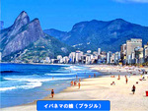

Oh, but I watch her so sadly
How can I tell her I love her
Yes, I would give my heart gladly ●
But each day as she walks to the sea
She looks straight ahead, not at me ●


LA CUMPALSITA
（演 奏）●
GIELITO LINDO
He happened to meet her, A sweet Senorita

One night at a gala fiesta

A picture in fine Spanish laces
with one of those pretty faces ●
Ay yi yi yi, He won my heart amigo
He said that he loved no one but me
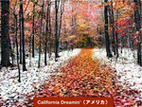
So off to the chapel we go-o ●
CALIFORNIA DREAMIN’

All the leaves are brown ( ) And the sky is gray ( )●
I’ve been for a walk ( ) On a winter’s day ( )
I’d be safe and warm ( ) If I was in L.A. ( ) ●

California dreamin’ ( ) On such a winter’s day (Ah---)●

KAIMANA HILA
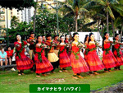
I wa ho makou i ka po nei ●
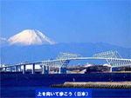
A ike ikanani kaimana Hila kaimana Hila
Kaumai luna ●

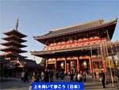

上を向いて歩こう
幸せは雲の上に ●
幸せは空の上に ●
上を向いて歩こう 涙がこぼれないように

泣きながら歩く ●
一人ぼっちの夜 ●

AROUND THE WORLD
Around the world I’ve searched for you
I traveled on when hope was gone
To keep a rendezvous

I knew somewhere sometime somehow
You look at me and I would see
The smile you’re smiling now ●

It might have been in country down
Or in New York in gay Paris or even London town
No more will I go around the world
For I have found my world in you

For I have found my world in you
Around the world ●

